1. **Change the number from base 2 to base 10. Show all work!**

| **Base 2** | **Base 10** |
| --- | --- |
| 11 2 | = 1 x 20 + 1 x 21  = 1 + 2  = 310 |
| 110 2 | 6 |
| 1001 2 | 9 |
| 1101 2 | 13 |
| 111 2 | 7 |
| 0011 2 | 3 |
| 110010 2 | 50 |
| 10101100 2 | 172 |
| 01000011 2 | 67 |

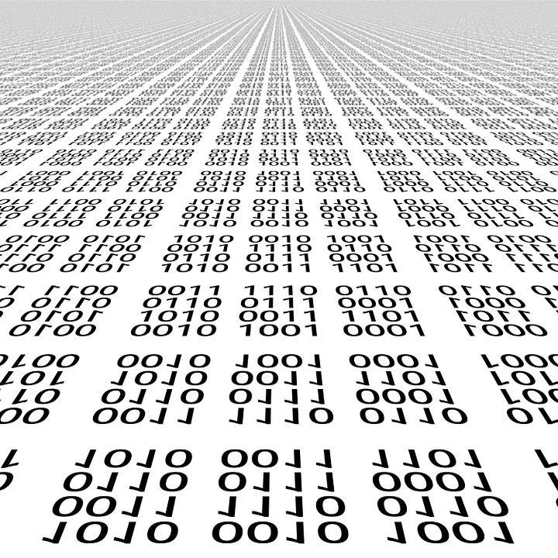

1. **Traditionally, modern computer systems stored *alpha-numberic* *characters* in eight-digit binary numbers known as “*bytes*”. Each digit within a byte is called a “*bit”*, which is (according to some sources) short for binary digit. Thus, eight bits in a byte. Yes, early Computer Scientists had a sense of humor!**

**The** [ASCII](https://en.wikipedia.org/wiki/ASCII) **standard has been used since the 1960s to associate numbers with characters, allowing computers to store text as a series of numbers.** **Part of the ASCII table is shown below. Translate the binary numbers in the second table to human-readable text. It will tell you why it is important to pay attention to detail when converting from base 2 (binary) to base 10 (decimal) ☺**

| **Binary** | **Character** |
| --- | --- |
| 01000101 | E |
| 01010110 | V |
| 01000101 | E |
| 01010010 | R |
| 01011001 | Y |
| 00100000 | SPACE |
| 01001100 | L |
| 01001001 | I |
| 01010100 | T |
| 01010100 | T |
| 01001100 | L |
| 01000101 | E |
| 00100000 | SPACE |
| 01000010 | B |
| 01001001 | I |
| 01010100 | T |
| 00100000 | SPACE |
| 01000011 | C |
| 01001111 | O |
| 01010101 | U |
| 01001110 | N |
| 01010100 | T |
| 01010011 | S |
| 00100001 | ! |

| **Decimal** | **Character** | **Decimal** | **Character** |
| --- | --- | --- | --- |
| **32** | (SPACE) | **79** | O |
| **33** | ! | **80** | P |
| **65** | A | **81** | Q |
| **66** | B | **82** | R |
| **67** | C | **83** | S |
| **68** | D | **84** | T |
| **69** | E | **85** | U |
| **70** | F | **86** | V |
| **71** | G | **87** | W |
| **72** | H | **88** | X |
| **73** | I | **89** | Y |
| **74** | J | **90** | Z |
| **75** | K |  |  |
| **76** | L |  |  |
| **77** | M |  |  |
| **78** | N |  |  |